IT 140 Design Document Template

Armincia Edwards 04/05/25 - *04/10/25

Storyboard (Description and Map)
"Gold and Ghouls," is a spooky, fantasy adventure set in the dilapidated mansion of the Winchesters. Legend has it, the Winchesters were once the wealthiest family in all the land, but their immense wealth was never enough. One day, they set out to seize the wealth of a powerful entity and in doing so angered this entity. It cost them their lives and the fortune they held so dear – never to be seen again. It is also said that even in death, the Winchesters took their greed with them. They haunt the halls of the old Winchester mansion, keeping all their treasures inside and anyone who dares to make off with them. The player takes on the role of a bold and arrogant thief who has heard of the demise of the Winchesters and seeks to be wealthier than they were by first raiding their mansion for all that was left. Their mission is to navigate the chilling, dangerously haunted Winchester mansion, locate all six piles of treasure, and escape before encountering the Winchesters, a family of violent, ghastly ghouls alerted by the thief’s intrusion. The player must loot carefully, as a premature encounter with the Winchesters before collecting the treasure will lead to a terrible end (defeat).
Rooms:
- The Grand Foyer: (Start Room - No Item) A cold and uninviting room with peeling wallpaper teeming with grandiose paintings of the Winchesters. The hall smells of mildew and feels devoid of all life ... because it is ... except for you ... for now. The paintings watch you foolishly march onward.
- A Vast Vestibule: The heart of the Winchester’s grandeur. Practically a ballroom that could host the party of the century. Now it lies dust-laden and grim. In the center of the room stands an opulent fireplace and upon its mantelpiece... your first treasure!
- Sir Winchester’s Private Study: Shelves filled with trinkets of worldly travel and expensive treasures line the walls. This room alone could make a good number of men rich beyond measure.
- Sir and Madam Winchester’s Chambers: The Winchesters sure knew how to sleep in style. Treasure adorns the walls and spills out onto the ornately designed rug that lies upon the creaking floorboards. Better be swift and quiet…
- The Kitchen: A large, well-equipped room, now sadly still and lifeless. You get a feeling that this was the most spectacular room in the whole mansion. The symphony of dishes, chefs, waiters, and lively chatter over the most exquisite meals… long extinguished. Oh well, these treasures will be darling in your kitchen!
- The Pantry: A spacious, long room that seems to stretch into forever. It is still stocked with so much food! Please… do not eat it. You may perish long before the Winchesters get you. What kind of treasure can be found here?
- The Winchester Children’s Chambers: It seems that even the Winchester children spent their days tucked away amongst a ridiculous amount of treasure! What could children even do with all this? Good thing you are here to give it all proper use.
- Mysterious Room: (Villain Room - No Item) An adjacent room on the opposite end of the hall connecting to the children’s room. As you consider approaching, an eerie feeling overcomes you. Then you hear sounds… children giggling… muffled sounds of a man and a woman yelling? Nobody is supposed to be here, not even you. Could it be the Winchesters? Perhaps whatever is in this room is best kept in its final resting place, unless you would like to meet yours?
Items:
- Faberge Egg: Found in A Vast Vestibule.
- Solid Gold Hunting Knife: Found in Sir Winchester’s Private Study.
- Ornate Jewel-Encrusted Jewelry Box: Found in Sir and Madam Winchester’s Chambers.
- Golden Dishes: Found in The Kitchen.
- Golden Box of Rare Spices: Found in The Pantry.
- Golden Bejewelled Figurines from Afar: Found in The Winchester Children’s Chambers.
Villains:
The Winchesters, the ghouls haunting the Winchester mansion. They guard their treasures in death with the greed that killed them. Those who risk their lives to retrieve any of these riches become a new resident… indefinitely. They are active during the player's adventure, so they must be quiet, swift and wise to survive.

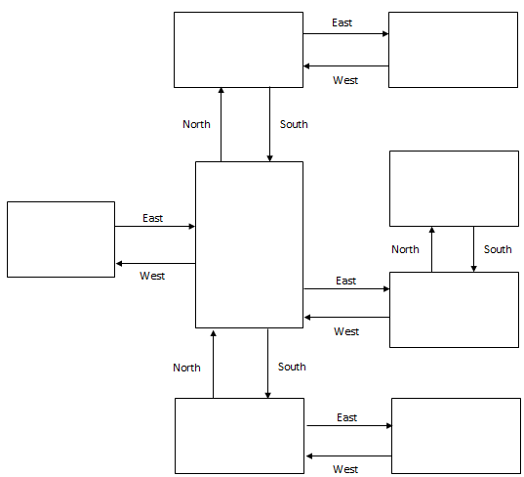

Pseudocode or Flowchart for Code to “Move Between Rooms”
START

Player inputs a direction:
IF player is in A Vast Vestibule
IF direction is North
Enter Sir Winchester’s Private Study
ELIF direction is South
Enter The Kitchen
ELIF direction is East
Enter The Winchester Children’s Chambers
ELIF direction is West
Enter The Grand Foyer
ELSE
Output shows Invalid Direction
Player inputs a direction:
IF player is in Sir Winchester’s Private Study
IF direction is South
Enter A Vast Vestibule
ELIF direction is East
Enter Sir and Madam Winchester’s Chambers
ELSE
Output shows Invalid Direction
Player inputs a direction:
IF player is in Sir and Madam Winchester’s Chambers
IF direction is West
Enter Sir Winchester’s Private Study
ELSE
Output shows Invalid Direction
Player inputs a direction:
IF player is in The Grand Foyer
IF direction is East
Enter A Vast Vestibule
ELSE
Output shows Invalid Direction
Player inputs a direction:
IF player is in The Kitchen
IF direction is North
Enter A Vast Vestibule
ELIF direction is East
Enter The Pantry
ELSE
Output shows Invalid Direction
Player inputs a direction:
IF player is in The Pantry
IF direction is West
Enter The Kitchen
ELSE
Output shows Invalid Direction
Player inputs a direction:
IF player is in The Winchester Children’s Chambers
IF direction is North
Enter Mysterious Room
ELIF direction is West
Enter A Vast Vestibule
ELSE
Output shows Invalid Direction
Player inputs direction:
If player is in Mysterious Room
If direction is South
Enter The Winchester Children’s Chambers
Else:
Output shows Invalid Direction
END

Pseudocode or Flowchart for Code to “Get an Item”
START
#When Player enters each room
#Display each inventory item [Faberge Egg, Solid Gold Hunting Knife, Ornate Jewel-Encrusted Jewelry Box, Golden Dishes, Golden Box of Rare Spices, Golden Bejewelled Figurines from Afar]

IF item is in room
Display item name
User selects add or leave item
IF add
Put in inventory
ELIF item already added to inventory
Leave item
ELIF leave item
Leave item
ELSE
Leave room

END

